Auckland University of Technology



ENME701 System Dynamics and Vibrations

Lab Report

Evaluation of Vibration Analysis Tools to Predict the Dynamic Integrity of a Truss Structure

Submitted by: Peter Smith
Student ID: 128434305

School of Engineering, Computer and Mathematical Science

2 March 2016

Table of Contents

1 Introduction (Use style Heading 1) 4
1.1 Objective (Use style Heading 2) 4
2 Strain Gage and Dial Indicator 4
2.1 Strain Gage and Dial Indicator Setup (using style Heading 3) 4
2.2 Strain Gage and Dial Indicator Results. 5
2.3 Natural Frequency Calculations 6
3 Finite Element Analysis 6
3.1 FEPC Model 6
3.2 FEPC Output 7
3.3 FEPC Calculations. 8
4 Lissajou Patterns 8
5 HP Signal Analyzer 8
5.1 Signal Analyzer Setup. 8
5.2 Signal Analyzer Results. 9
6 Comparison and Analysis of Tools 9
6.1 Tool Accuracy. 10
6.2 Tool Cost. 10
6.3 Tool Time and Effort Requirement. 11
6.4 Tool Choice. 11
7 Truss Redesign 11
8 Conclusion 11
9 References 12
10 Appendices 13

Introduction (Use style Heading 1)
In this lab, we tested several tools for evaluating the static and dynamic integrity of the frame structure of the Model 53 Air Conditioner. In our tests, we found that the best method for finding the stresses in each truss member was the finite element method and the best method for finding the natural frequency of the system was the Lissajou method. Our results also showed that the natural frequency of the system was approximately 130 rad/sec for a 28-lb load and 100 rad/sec for a 56-lb load.
This information was found by following our tutor’s advice in the setup of the truss frame analysis. After setting up the truss and shaker, which simulates the air conditioner’s vibration, we used several different tools to determine the member stresses and natural frequency of the truss frame. Those tools were as follows: finite element program, Lissajou patterns, HP signal analyzer, and strain gages and a dial indicator. Each of these tools and the results that we obtained from each method are described in their own self-titled sections of this report.
Following the descriptions and results of each method is a comparison of these tools. The tools were compared based on accuracy, cost, and time and effort required. The Lissajou method was found to be the easiest to use and produced accurate natural frequency results at a relatively low cost. The finite element method required the least amount of time and money, yet produced very inaccurate natural frequency results compared with the other tools. The finite element method did accurately predict the stresses in each member with little cost and time required, so it is the preferred choice for static analysis. These results are further detailed in the “Comparison and Analysis of Tools” subsection of this report.
In addition, we have also included some possible redesigns of the truss frame that will increase the first resonance of the truss and air conditioner in order to avoid operating at the first natural frequency of this system. This discussion is included in the “Truss Redesign” section of this report.

Objective (Use style Heading 2)
The objectives of this laboratory session are to evaluate the different vibration analysis tools to predict the dynamic integrity of a truss structure.

Strain Gage and Dial Indicator
This section outlines the setup and data collection, results and analysis, and natural frequency calculations obtained using the strain gages and dial indicator.

Strain Gage and Dial Indicator Setup (using style Heading 3)
The six strain gages were set up as shown in Figure 1. Three of these strain gages were attached to the front half of the truss frame, and three were mounted to the rear truss. The positions of the three front gages are each highlighted in Figure 1 by yellow circles. The dial indicator measured the deflection of the pin joint that is encircled by the red oval.
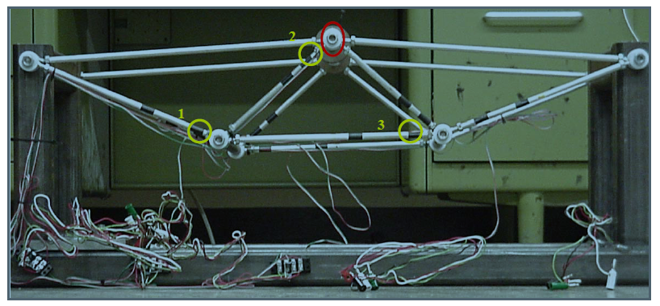
Figure 1. Truss setup. The yellow circles indicate the position of the front three strain gages. The red oval shows where the dial indicator measured deflection. (using Figure Caption)
After reviewing the setup of the strain gages, we referred to [1] that outlined some calculations (see Appendix A). These calculations described how to calibrate the strain gages and interpret the output from the strain indicator. However, close review of Zima’s calculations revealed that an error existed in his last two equations. The correction is reflected in the Appendix and in equations 1 and 2, which we used to interpret the strain indicator’s output, V_{s,out}
$-181µε=V_{s,out}G_{amp}$ (1)
$V_{strain}=\frac{1}{2}V_{out}G_{amp}$ (2)
where G_{amp} is a factor (not gage factor) that takes into account amplification in the strainindicator box, V_{strain} is the actual strain, and V_{out} is the output from the strain indicator box.
After revising these equations, we collected data from each of the six strain gages. Two 14-lb weights were positioned at the top center of the truss frame. We then tabulated the strain indicator reading (V_{out}) for each strain gage with the 28-lb load. After adding two more 14-lb weights, we repeated the data collection with a total of 56 lbs supported by the truss. Surprisingly, our data for the front truss was very different from that of the back truss. Because the structure is symmetrical, we expected that the data would match closely. After zeroing the strain indicator box for each strain gage, we took readings at zero, subtracted those readings from our 28-lb and 56-lb readings, and noted much better results.

Strain Gage and Dial Indicator Results.
The results from the strain gages for the 28-lb and 56-lb loads are shown in Table 1. Theoretically, the data for front and back gage positions should match. For gage positions two and three, good agreement exists, but for position one, there is a fairly large discrepancy. We took additional measurements for the back truss in position one and obtained different measurements (off by up to 300μV). This discrepancy made us question the results for that position and to trust the front side readings more. We used equation 2 to calculate the strain for each of these positions. From the dial indicator, we measured a deflection of 0.0235 inches under a 28-lb load. When 56 lbs were applied, a deflection of 0.037 inches was noted.
Table 1. Strain gage data (using Table Caption)
Gage | 1_{front} | 2_{front} | 3_{front} | 1_{back} | 2_{back} | 3_{back}
V_{28lb} (µV) | 88 | -48 | 128 | 196 | -56 | 126
ε_{28lb}(µε) | 44 | -24 | 64 | 98 | -28 | 63
V_{56lb}(µV) | 188 | -104 | 250 | 288 | -114 | 254
ε_{56lb}(µε) | 94 | -52 | 125 | 144 | -57 | 127

Natural Frequency Calculations
In order to compare the dial indicator to our other tools, we needed to be able to compare natural frequencies measured by each of the tools. To calculate this natural frequency, we have
(3)
where F is the load experienced by the system, x is the deflection measured by the dial indicator, and m_{total} is the total mass of the system including the load (simulating the air conditioner), steel crossbars, and aluminum truss members. To calculate the natural frequency for each load, we used our deflection measurements of 0.0235 in. (for 28-lb load) and 0.037 in. (for 56-lb load). Then we calculated a natural frequency of 120.9 rad/sec for the 28-lb load and 99.1 rad/sec for the 56-lb load. These calculations (and other natural frequency calculations) are included in Appendix B.

Finite Element Analysis
In order to perform the finite element analysis of this truss frame, we used a program called the Finite Element Personal Computer Processor (FEPC), written by Dr. Charles Knight [2]. Outlined in the following section are the constraints used in the finite element model, the output data from FEPC, and the calculations used to determine the natural frequency of the truss frame.

FEPC Model
FEPC needs information about the truss (element type, material properties, node positions, etc.) to be entered into the FEPC input processor in order to determine how the truss will react under a certain loading. Our first choice in modeling this structure was to use symmetry to simplify our model. Because the front and the back halves of the structure are symmetric, we were able to model just the front of the truss.
Next, we chose to use a truss element type. This assumption is a good one because each member is slender, a two-force member, and joined by pins [2]. The material properties that FEPC requires are the modulus of elasticity and the cross-sectional area of the truss members. After finding the modulus of elasticity of aluminum to be 10.3×106 psi according to [3], we calculated a cross-sectional area of 0.045 inch². Our next step was to define the nodes to represent our pin joints. The x and y coordinates for node positions that we used are listed in Appendix C and correspond to the numbered nodes in Figure 2. Also shown in Figure 2 are the boundary conditions, symbolized by the triangles on nodes 1 and 3. These two pin joints are assumed to be fixed in the x and y direction. Two FEPC models were made—one had a 14-lb load and the other had 28 lbs. These loads were each modeled as a downward force applied to the pin joint at node 2.
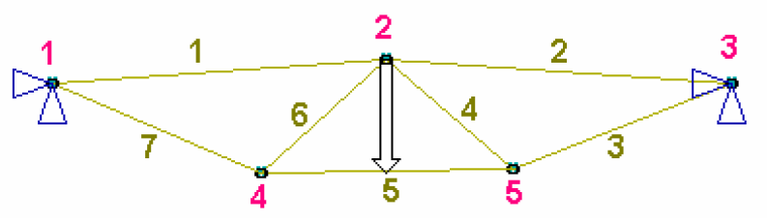
Figure 2. FEPC model of truss front with 28-lb force.

FEPC Output
After the constraints were input into FEPC, the model processed those constraints and gave the stress and deflection for each member. These results are tabulated in Tables 2 and 3. A printout from FEPC including the input constraints and FEPC’s output is also included in Appendix D.
Table 2. Deflection estimated by FEPC
Node | Deflection (in.)  for 14 lbs | Deflection (in.)  for 28 lbs
1 | 0.00000 | 0.00000
2 | 0.00289 | 0.00548
3 | 0.00000 | 0.00000
4 | 0.00210 | 0.00399
5 | 0.00225 | 0.00427

Table 3. Stresses estimated by FEPC
Element | Stress (psi)  for 14 lbs | Stress (psi)  for 28 lbs
1 | -107.6 | -204.3
2 | -130.3 | -247.5
3 | 455.0 | 864.1
4 | -236.5 | -449.1
5 | 606.0 | 1151.0
6 | -270.3 | -513.4
7 | 436.4 | 828.7

FEPC Calculations.
To compare FEPC’s accuracy to the accuracy of the strain gages, we calculated strain from the stresses shown in Table 3. To perform this computation, we used equation 4:
(4)
where ε is strain, σ is the stress predicted by FEPC, and E is the modulus of elasticity of aluminum. We also calculated the natural frequency estimated by FEPC so that we could compare its accuracy with that of the HP signal analyzer and the Lissajou patterns. We used equation 3 and calculated 345 rad/sec for a 28-lb air conditioner and 258 rad/sec for a 56-lb load. These natural frequency calculations are included in Appendix B.

Lissajou Patterns
After completing our static and finite element analysis, we started dynamic analysis. Using a sinusoidal input and an oscilloscope output, we were able to view the Lissajou patterns. At a frequency below resonance, the oscilloscope outputs a diagonal line with a slope of unity. When the frequency is greater than the resonance frequency, the oscilloscope outputs a diagonal line with a slope of negative one. This method is very effective for finding the natural frequency because when the system hits resonance, the oscilloscope outputs a circle as shown in Figure 3.
Figure 3. Lissajou patterns.
Using this method, we found the lowest natural frequency to be 134.3 rad/sec (21.4 Hz) for a 28-lb load. In addition, we determined the second lowest natural frequency, which was 749 rad/sec (119 Hz). Because the shaker was unable to move such a large mass, we were not able to simulate the 56-lb load for dynamic testing.

HP Signal Analyzer
Another part of our dynamic analysis was to determine the natural frequency by using the HP signal analyzer. This section describes our procedure in setting up the signal analyzer and the results that we obtained from it.

Signal Analyzer Setup.
The equipment for the dynamic tests using the signal analyzer included the Hewlett-Packard signal analyzer, a speaker amplifier system, a shaker, and force and accelerometer gages. First, we ran the equipment according to the instructions posted in the laboratory. In doing so, we were careful not to turn on the speaker system until we had already turned on the signal analyzer so that the transient pulse would not destroy the equipment.
Next we set up the HP signal analyzer to transmit a random frequency to the shaker. The response of the system was sensed by the accelerometer gage and transmitted back to the signal analyzer. The Hewlett-Packard machine then sorted the frequencies and created a bode plot showing the frequency response function. The tabulated data were recorded.

Signal Analyzer Results.
Using Matlab, we recreated the bode plot from this data. This Matlab code (and our initial data) is included in Appendix E. Shown in Figure 4 is the bode plot of our frequency response function (FRF) is shown. Although this plot shows the function for frequencies from only 10 to 100 Hz, a bode plot showing our full range of frequencies is included in Appendix F. From this bode plot, we found the natural frequency by moving the green line (representing natural frequency) until the red and green and blue lines all crossed at the same point on the phase plot. To obtain the highest degree of accuracy, we magnified the graph in Matlab. The natural frequency line plotted in Figure 4 represents a natural frequency of 21.6 Hz (135.8 rad/sec). This measurement closely matches the natural frequency found from the Lissajou plot.

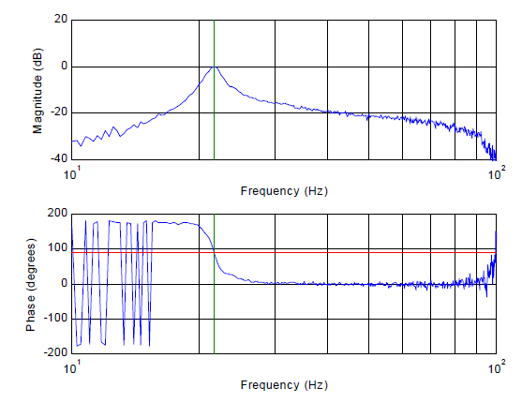
Figure 4. Bode plot of frequency response function. The green line represents the natural frequency of 21.6 Hz. The red line shows a phase angle of 90°.

Comparison and Analysis of Tools
After using each of these tools to determine the static and dynamic properties of the truss frame, we compared the various tools based on accuracy, cost, and ease of use. For measuring the natural frequency, we found that the HP signal analyzer is most accurate, that FEPC is least expensive, and that the Lissajou method requires the least time and effort. For measuring stresses, we found that FEPC is easier to use than the strain gages.

Tool Accuracy.
Table 4 shows a comparison of the natural frequency measured or estimated by each of the tools when the frame is under a 28-lb load. Notice that there is good agreement between all the tools that measured natural frequency and that FEPC’s estimation of the natural frequency differs from the experimental values by a factor of almost three.
Table 4. Comparison of the natural frequency found by each tool.
Tool | (rad/sec) | (Hz)
Strain Gage | 120.9 | 19.2
FEPC | 345.0 | 54.9
Lissajou Pattern | 134.3 | 21.4
HP Signal Analyzer | 135.8 | 21.6
Of all the tools used to find the natural frequency, it seems that the Hewlett-Packard signal analyzer is the most accurate. Although the bode plot in Figure 4 shows some noise at low and high frequencies, the curve is very smooth near resonance. While the signal analyzer is probably most accurate, the Lissajou is a close second.
Table 5 shows a comparison of the strain measurements from FEPC and from the strain gages. The figures in this table reflect the stress of three members under a 28-lb load. For the strain gages, the data from the front half of the structure was used. Because there is good agreement between FEPC and the strain gages, I conclude that they are equally accurate for determining truss member stresses.
Table 5. Comparison of stress determined using FEPC and strain gages
FEPC Element | Strain Gage Element | FEPC Stress (psi) | Strain Gage Stress (psi)
7 | 1 | 436.4 | 453.2
6 | 2 | -270.3 | -247.2
5 | 3 | 606.0 | 659.2

Tool Cost.
The cost of each tool is detailed in Table 6. Notice that since FEPC is freeware, it is clearly the least expensive tool. The HP signal analyzer is by far the most expensive tool and even though it is more accurate than the Lissajou pattern, its extreme cost factor makes it an unlikely first choice.
Table 6. Comparison of tool cost
Tool | Estimated Cost
Strain Gage | $100
FEPC | Free
Lissajou Pattern | $2000
HP Signal Analyzer | $21,000

Tool Time and Effort Requirement.
Another important cost factor to consider is that of human labor. For instance, while FEPC may be free, the cost of hiring personnel to run that program may be quite high. Of all the tools, though, I feel that the time and effort required to use the strain gages is the highest. Each strain gage has to be painstakingly made and attached to the frame. Then, numerous calculations have to be performed in order to analyze the output of the strain indicator box. Compared with the strain gage method, all of the other methods require little time and effort. Of these, the easiest and quickest method was the Lissajou method.

Tool Choice.
Based on the accuracy, cost, and time required for each of these tools, we decided that the Lissajou method was the best tool to use for determining the natural frequency. It was almost as accurate as the HP signal analyzer. Although it was not the least expensive tool, its cost of approximately $1000 is easily affordable for a technical company. In addition, the Lissajou method required far less time and effort than did each of the other tools. For measuring stresses, FEPC is a better tool choice than the strain gages because FEPC was equally accurate, was less expensive, and required less time and effort.

Truss Redesign
Although we have chosen a satisfactory tool to measure the natural frequency, we have not found a way to avoid operating at the lowest natural frequency of the system (about 130 rad/sec). It was recommended that we should indicate ways to adjust the truss to avoid our natural frequency, ϖ_{n}, that we have calculated. While we do not know the operating frequency of the air conditioner, either of the two following adjustments can be made to the truss in order to increase its natural frequency once the air conditioner’s operating frequency is found. One truss adjustment is to increase the diameter of the aluminum truss members. Another option is to shorten the lengths, L, of the truss members. These observations are based on equations 5 and 6:
(5)
(6)
where k is the stiffness, A is the cross-sectional area, E is the modulus of elasticity, and m is the mass of the system.

Conclusion
In conclusion, the best method for finding the natural frequency of the system is the Lissajou method. It far surpassed the finite element method in accuracy. The HP signal analyzer was also ruled out because it was simply too expensive to warrant the small improvement in accuracy that it provided. Also, the strain gages and dial indicators were undesirable because of the time and effort required to get results. For measuring member stresses, we found that FEPC was superior to the strain gages due to accurate results, inexpensive software cost, and ease of use. We also found that the natural frequency of the system was approximately 130 rad/sec for a 28-lb load and 100 rad/sec for a 56-lb load. By increasing the diameter or decreasing the length of the aluminum truss members, the resonant frequency could be avoided. For future tests I recommend increasing the truss diameters, using the Lissajou method to measure the natural frequency, and using FEPC to determine the stresses of the truss members.

References
[1] Zima, Drew, “Shunt Resistor Calculations,” handout in ME 4006 (Blacksburg, VA: Mechanical Engineering Department, 3 September 2001).
[2] Knight, Charles E., The Finite Element Method in Mechanical Design (Boston: PWSKent Publishing Company, 1993), p. 18.
[3] Shigley, Joseph, and Larry Mitchell, Mechanical Engineering Design, 4th ed. (New York: McGraw-Hill, Inc., 1993), p. 800.

Appendices
Appendix A: Shunt Resistor Calculations

Appendix B: Natural Frequency Calculations

Appendix C: Node Positions Used in FEPC

Appendix D: Printouts From FEPC

Appendix E: Matlab Code for Dynamic Analysis

Appendix F: Bode Plot Showing All Data Collected

